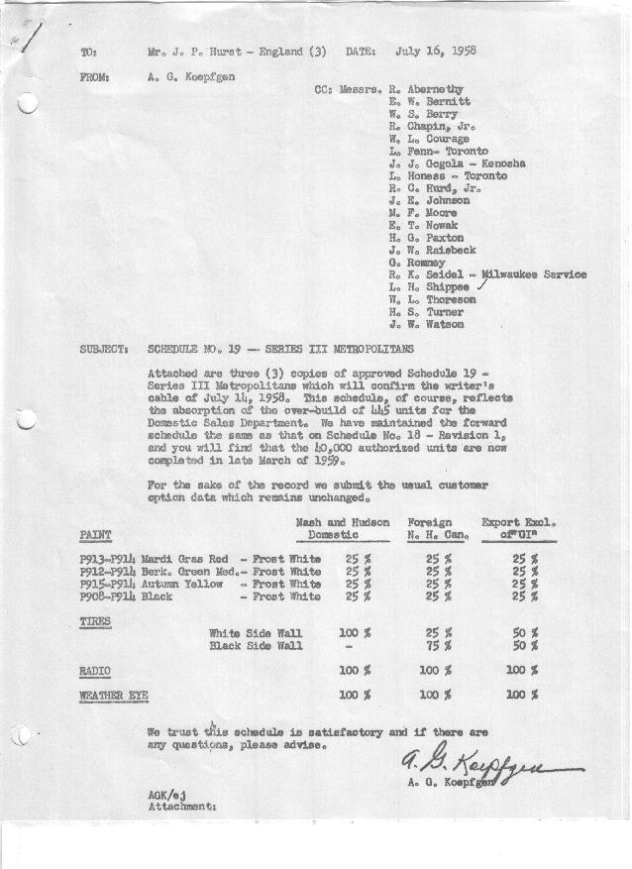

FORM AM 1262 Page 1 of 2 APPROVED R. Abernethy (signed) DATE 7/16/58

SCHEDULE NO. ______19 ___ DATE 7/15/58 MONTHLY BUILDING SCHEDULE APPROVED R. W.Chapin Jr. (signed) DATE_ 7/17/58 _
REVISION NO. _______ ______ DATE PRODUCT APPROVED E.W.Bernitt (signed) DATE _ 7/17/58 ____
SERIES III 1500 c.c. ENGINE
METROPOLITAN SERIES CARS – AUSTIN MOTORS CO., LTD, ENGLAND
DESCRIPTION | BUILT  ◻ACT EST  THRU  JUNE | FIRM BUILDING SCHEDULE  (FABRICATED MATERIAL RELEASE) |  |  |  |  |  |  |  |  |  |  |  |  |  |  | TENTATIVE SCHEDULE  (RAW MATERIAL RELEASED) |  |  | GRAND  TOTAL
DESCRIPTION | BUILT  ◻ACT EST  THRU  JUNE | MONTH JULY  DAYS 19 |  |  | MONTH AUGUST  DAYS 15 |  |  | MONTH SEPTEMBER  DAYS 22 |  |  | MONTH OCTOBER  DAYS 23 |  |  | MONTH NOVEMBER  DAYS 20 |  |  | MONTH DECEMBER  DAYS 21 |  |  | GRAND  TOTAL
DESCRIPTION | BUILT  ◻ACT EST  THRU  JUNE | DAILY | MONTH | CUM’L  TOTAL | DAILY | MONTH | CUM’L  TOTAL | DAILY | MONTH | CUM’L  TOTAL | DAILY | MONTH | CUM’L  TOTAL | DAILY | MONTH | CUM’L  TOTAL | DAILY | MONTH | CUM’L TOTAL | GRAND  TOTAL
DOMESTIC LHD:
Hard-Top | 23145 |  | 836 | 23981 |  | 687 | 24668 |  | 983 | 25651 |  | 1054 | 26705 |  | 585 | 27290 |  | 681 | 27971
Soft-Top | 3884 |  | 112 | 3996 |  | 99 | 4095 |  | 121 | 4216 |  | 117 | 4333 |  | 65 | 4398 |  | 76 | 4474
Total U.S. | 27029 | 49.9 | 948 | 27977 | 52.4 | 786 | 28763 | 50.2 | 1104 | 29867 | 50.9 | 1171 | 31038 | 32.5 | 650 | 31688 | 36.0 | 757 | 32445
Over/(Under) Schedule 18 R.1 | 500 |  | (55) | 445 |  | -0- | 445 |  | -0- | 445 |  | -0- | 445 |  | -0- | 445 |  | -0- | 445
FOREIGN:
EXPORT LHD Hard-Top | 754 |  | 35 | 789 |  | 15 | 804 |  | 35 | 839 |  | 35 | 874 |  | 35 | 909 |  | 35 | 944
Soft-Top | 348 |  | 16 | 364 |  | 10 | 374 |  | 15 | 389 |  | 15 | 404 |  | 15 | 419 |  | 15 | 434
Total Export LHD | 1102 |  | 51 | 1153 |  | 25 | 1178 |  | 50 | 1228 |  | 50 | 1278 |  | 50 | 1328 |  | 50 | 1378
RHD Hard Top | 351 |  | 27 | 378 |  | 12 | 390 |  | 20 | 410 |  | 12 | 422 |  | 20 | 442 |  | 12 | 454
Soft Top | 58 |  | 12 | 70 |  | 3 | 73 |  | 5 | 78 |  | 3 | 81 |  | 5 | 86 |  | 3 | 89
Total Export RHD | 409 |  | 39 | 448 |  | 15 | 463 |  | 25 | 488 |  | 15 | 503 |  | 25 | 528 |  | 15 | 543
Total Export LHD & RHD | 1511 | 4.7 | 90 | 1601 | 2.7 | 40 | 1641 | 3.4 | 75 | 1716 | 2.8 | 65 | 1781 | 3.7 | 75 | 1856 | 3.1 | 65 | 1921
Over/(Under) Schedule 18 R.1 | (40) |  | 40 | -0- |  | -0- | -0- |  | -0- | -0- |  | -0- | -0- |  | -0- | -0- |  | -0- | -0-
CANADA Hard-Top | 2390 |  | 25 | 2415 |  | 25 | 2440 |  | 70 | 2510 |  | 70 | 2580 |  | 77 | 2657 |  | 20 | 2677
Soft-Top | 240 |  | -0- | 240 |  | -0- | 240 |  | -0- | 240 |  | -0- | 240 |  | -0- | 240 |  | -0- | 240
Total Canada | 2630 | 1.3 | 25 | 2655 | 1.7 | 25 | 2680 | 3.2 | 70 | 2750 | 3.1 | 70 | 2820 | 3.9 | 77 | 2897 | 1.0 | 20 | 2917
Over/(Under) Schedule 18 R.1 | -0- |  | -0- | -0- |  | -0- | -0- |  | -0- | -0- |  | -0- | -0- |  | -0- | -0- |  | -0- | -0-
Total Foreign | 4141 | 6.0 | 115 | 4256 | 4.3 | 65 | 4321 | 6.6 | 145 | 4466 | 5.9 | 135 | 4601 | 7.6 | 152 | 4753 | 4.1 | 85 | 4838
Over/(Under) Schedule 18 R.1 | (40) |  | 40 | -0- |  | -0- | -0- |  | -0- | -0- |  | -0- | -0- |  | -0- | -0- |  | -0- | -0-
GRAND TOTALS
Hard-Top | 26640 | 48.6 | 923 | 27563 | 49.3 | 739 | 28302 | 50.4 | 1108 | 29410 | 50.9 | 1171 | 30581 | 35.8 | 717 | 31298 | 35.6 | 748 | 32046
Soft-Top | 4530 | 7.3 | 140 | 4670 | 7.4 | 112 | 4782 | 6.4 | 141 | 4923 | 5.9 | 135 | 5058 | 4.3 | 85 | 5143 | 4.5 | 94 | 5237
Total | 31170 | 55.9 | 1063 | 32233 | 56.7 | 851 | 33084 | 56.8 | 1249 | 34333 | 56.8 | 1306 | 35639 | 40.1 | 802 | 36441 | 40.1 | 842 | 37283
Over/(Under) Schedule 18 R.1 | 460 |  | (15) | 445 |  | -0- | 445 |  | -0- | 445 |  | -0- | 445 |  | -0- | 445 |  | -0- | 445

FORM AM 1262 Page 2 of 2 APPROVED R. Abernethy (signed) DATE 7/16/58

SCHEDULE NO. ______19 ___ DATE 7/15/58 MONTHLY BUILDING SCHEDULE APPROVED R. W.Chapin Jr. (signed) DATE_ 7/17/58 _
REVISION NO. _______ ______ DATE PRODUCT APPROVED E.W.Bernitt (signed) DATE _ 7/17/58 ____
SERIES III 1500 c.c. ENGINE
METROPOLITAN SERIES CARS – AUSTIN MOTORS CO., LTD, ENGLAND
DESCRIPTION | BUILT  ◻ACT◻ EST  THRU | FIRM BUILDING SCHEDULE  (FABRICATED MATERIAL RELEASE) |  |  |  |  |  |  |  |  |  |  |  |  |  |  | TENTATIVE SCHEDULE  (RAW MATERIAL RELEASED) |  |  | GRAND  TOTAL
DESCRIPTION | BUILT  ◻ACT◻ EST  THRU | MONTH JANUARY 1959  DAYS 22 |  |  | MONTH FEBRUARY  DAYS 20 |  |  | MONTH MARCH  DAYS 17.5 |  |  | MONTH APRIL  DAYS |  |  | MONTH  DAYS |  |  | MONTH  DAYS |  |  | GRAND  TOTAL
DESCRIPTION | BUILT  ◻ACT◻ EST  THRU | DAILY | MONTH | CUM’L  TOTAL | DAILY | MONTH | CUM’L  TOTAL | DAILY | MONTH | CUM’L  TOTAL | DAILY | MONTH | CUM’L  TOTAL | DAILY | MONTH | CUM’L  TOTAL | DAILY | MONTH | CUM’L TOTAL | GRAND  TOTAL
DOMESTIC LHD:
Hard-Top |  |  | 688 | 28659 |  | 573 | 29232 |  | 633 | 29865
Soft-Top |  |  | 94 | 4568 |  | 143 | 4711 |  | 200 | 4911
Total U.S. |  | 35.5 | 782 | 33227 | 35.8 | 716 | 33943 | 50.0 | 833 | 34776
Over/(Under) Schedule 18 R.1 |  |  | -0- | 445 |  | -0- | 445 |  | (267) | 178
FOREIGN:
EXPORT LHD Hard-Top |  |  | 35 | 979 |  | 35 | 1014 |  | 35 | 1049
Soft-Top |  |  | 15 | 449 |  | 10 | 459 |  | 6 | 465
Total Export LHD |  |  | 50 | 1428 |  | 45 | 1473 |  | 41 | 1514
RHD Hard Top |  |  | 20 | 474 |  | 12 | 486 |  | 20 | 506
Soft Top |  |  | 5 | 94 |  | 3 | 97 |  | 5 | 102
Total Export RHD |  |  | 25 | 568 |  | 15 | 583 |  | 25 | 608
Total Export LHD & RHD |  | 3.4 | 75 | 1996 | 3.0 | 60 | 2056 | 3.0 | 66 | 2122
Over/(Under) Schedule 18 R.1 |  |  | -0- | -0- |  | -0- | -0- |  | -0- | -0-
CANADA Hard-Top |  |  | 15 | 2692 |  | 10 | 2702 |  | 85 | 2787
Soft-Top |  |  | 10 | 250 |  | 15 | 265 |  | 50 | 315
Total Canada |  | 1.1 | 25 | 2942 | 1.3 | 25 | 2967 | 6.1 | 135 | 3102
Over/(Under) Schedule 18 R.1 |  |  | -0- | -0- |  | -0- | -0- |  | -0- | -0-
Total Foreign |  | 4.5 | 100 | 4938 | 4.3 | 85 | 5023 | 9.1 | 201 | 5224
Over/(Under) Schedule 18 R.1 |  |  | -0- | -0- |  | -0- | -0- |  | -0- | -0-
GRAND TOTALS
Hard-Top |  | 34.5 | 758 | 32804 | 31.5 | 630 | 33434 | 46.3 | 773 | 34207 |  | -0- | 34207
Soft-Top |  | 5.6 | 124 | 5361 | 8.6 | 171 | 5532 | 12.8 | 261 | 5793 |  | -0- | 5793
Total |  | 40.1 | 882 | 38165 | 40.1 | 801 | 38966 | 59.1 | 1034 | 40000 |  | -0- | 40000
Over/(Under) Schedule 18 R.1 |  |  | -0- | 445 |  | -0- | 445 |  | (267) | 178 |  | (178) | -0-

